Split Brain Patient Worksheet
NAME: ___________________________ DATE: ______________
- In which hemisphere of the brain are the language areas most likely located?

- When it comes to vision, the right visual field is perceived in the _____________ hemisphere and the left visual field is perceived in the ________________ hemisphere.

- On the drawing below, label the language area of the brain.

- On the drawing below, label the visual area of the brain.

- Draw two eyeballs in front of the brain. Remember how both eyes are involved in both visual fields. After drawing the two eyeballs, using two different colors of pen/pencils, draw how each visual field makes its way to the occipital lobes.
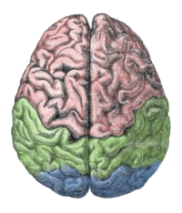

Image source: https://en.wikipedia.org/wiki/Human_brain

- Now assume that the corpus callosum is severed; what happens when the corpus callosum is severed?

- Assume that a split-brain patient was looking at the diagram below while focusing both eyes on the cross in the middle. Now, draw a line from each word to the area and side of the brain where each word would be perceived.
scape
land

Image source: https://en.wikipedia.org/wiki/Human_brain
- Now, comparing the two brain diagrams and their labels, write which word could be spoken aloud by the split-brain patient.

- Remembering which side of the brain controls the right side of the body and vice versa, write down the word which the patient would point to with their left hand. If it helps, draw on the brain, which side of the brain controls which hand.

